Consultancy Terms of Reference:
SPOTT-assessed Company Engagement for Indonesia & Malaysia

ZSL’s Sustainable Business programme is seeking a consultant to support outreach and engagement with SPOTT-assessed companies in the timber, palm oil and natural rubber sectors operating in Indonesia and Malaysia. The consultant will act as an ambassador for SPOTT, raising awareness or the SPOTT project and the need for corporate disclosure on sustainability issues, as well as providing support on how to improve corporate disclosure and transparency around ESG issues covered by the SPOTT indicator framework.

What is SPOTT?

SPOTT – Sustainability Policy Transparency Toolkit – is a free, online platform supporting sustainable commodity production and trade. By tracking transparency, SPOTT incentivises the implementation of corporate best practice. Investors, buyers and other key influencers can use SPOTT assessments to inform stakeholder engagement, manage ESG risk, and increase transparency across multiple industries.

SPOTT assesses commodity producers, processors and traders on their public disclosure regarding their organisation, policies and practices related to environmental, social and governance (ESG) issues. SPOTT scores tropical forestry, palm oil and natural rubber companies annually against over 100 sector-specific indicators to benchmark their progress over time.

In 2020, SPOTT-assessed 230 soft-commodity companies globally:
- 100x timber and pulp companies - 15 operating in Indonesia, 8 in Malaysia (see list here)
- 100x palm oil companies (see list here)- 52 operating in Indonesia, 28 in Malaysia
- 30x natural rubber companies (see list here)

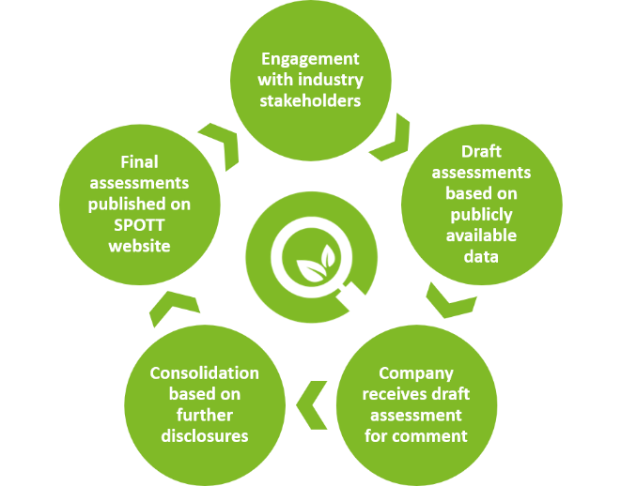
SPOTT & company engagement

Corporate ESG disclosure generally improves when companies engage with SPOTT to discuss their draft scores with the SPOTT team, understand the framework and then incorporate SPOTT’s feedback. During the evaliation process, assessors send a preliminary assessment to companies, which then have the opportunity to provide feedback to the SPOTT team, update their policies and procedures and resubmit evidence ahead of final evaluation (see SPOTT engagement process image to the right)

The role of the Consultant will be to drive increased engagement with SPOTT-assessed companies by collecting up-to-date contact information with the companies in question, setting up remote meetings with companies in Indonesia and Malaysia, in order to introduce the SPOTT initiative, explain scoring and assessment methodology, as well as gathering feedback and answering questions on annual assessments. This process will be supported by the SPOTT project team located in the UK.

As such, ZSL is seeking a consultant with experience interacting with soft-commodity supply chain companies for the provision of sustainability support to lead on our outreach with companies in South East Asia which are assessed on the SPOTT platform.

Deliverables

- Company research: Conduct detailed research in order to review and revise SPOTT database of company information. This will include research on company structures, contact details, and other information important for outreach (phone numbers, location addresses, email addresses, known subsidiaries and parent companies, landbank and concession data).

- Translation of relevant SPOTT materials for outreach and engagement (emails, powerpoint presentation and factsheet).

- Establish contact with key staff at SPOTT-assessed companies: The consultant shall contact organisations and introduce the SPOTT project to relevant staff. This step involves remote engagement via Telephone, Skype, Teams, Whatsapp, email or other locally appropriate platforms. Introductions to the SPOTT project team will be required to demonstrate fulfilment of this deliverable.

- Assessment Support:
  - Follow-up calls with companies: Calls to timber and pulp companies (June 2021), and palm oil companies (August/September 2021) and rubber companies (Dec/Jan 2022) to ensure they have received draft SPOTT assessments and gather any feedback directly.
  - Feedback to companies on SPOTT assessments: Assistance during the assessment period in providing translated feedback to companies who respond to assessments as well as follow up calls with companies to ensure they have received and understood SPOTT feedback.

- Maintain engagement records: The consultant shall maintain a shared spreadsheet with the SPOTT team which shall be updated (at least) bi-weekly, showing company details (see point 1 above), as well as status of engagement with each company, last activity, feedback for the SPOTT team.

NOTE: Resources should be allocated primarily to SPOTT-assessed companies which have not previously engaged with SPOTT. Engagement levels for each commodity sector can be seen on the SPOTT assessment rankings. See 2020 Timber & Pulp rankings here.

Requirements

All requirements below are mandatory unless stated as desirable.

- Fluency in Bahasa Indonesia and/or Malay
- Excellent knowledge of the Indonesian and/or Malaysian timber, palm oil and/or natural rubber sectors.
- Good contact network within these sectors (desirable)
- Demonstrated understanding of sustainable forestry and agricultural best practice requirements.
- Understanding of assessment and reporting schemes or sustainability certification schemes (such as FSC, PEFC, RSPO).
- Excellent communicator, able to distil and summarise complex information in an understandable way.

Contract Value

The total budget for the contract shall not exceed £6,000.

Timelines

The contract period will cover up to 1 year from March 2021 to March 2022.

This may be shorter based on a clear and costed workplan presented by the consultant which delivers the desired impact and meets all deliverables specified above.

Submission requirements:

Applicants shall submit:
- A short (<5 page) proposal, outlining their suitability for the contract, strategy and workplan, timelines and any other considerations.
- CVs of all staff who will/may work on the contract.
- Budget clearly showing the number of days allocated to the contract and each deliverable, as well as day rates applied to all staff. Plus, any expenses included.

For more information or to ask questions regarding this ToR, the consultant may contact Oliver Cupit (Sustainable Business Programme Manager) at oliver.cupit@zsl.org

Submission deadline:
Submission of final proposals should be sent to Oliver Cupit (Sustainable Business Programme Manager) at oliver.cupit@zsl.org by midnight 28th February 2021.

